30.07.2020
Lab-III-HTML Semantics and basic CSS

1.
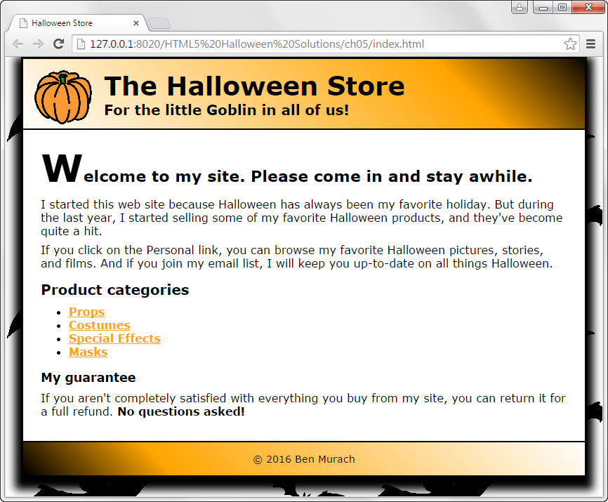

2. Design the page linked as "Page_to_design" based on the given Layout.
Requirements: content and images
